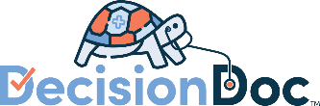
BJ’s Restaurants
Benefit Guide Language

Standalone Introduction to Decision Doc
Use this section to introduce Decision Doc. Include the screenshot below so it’s familiar to employees!
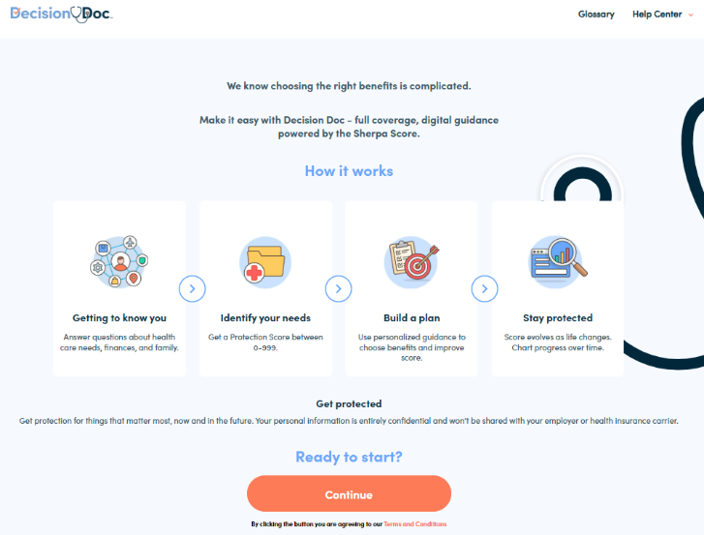
Decision Doc
Choosing the right benefits is complicated. Make it easy with Decision Doc – full coverage, digital guidance. This is a free, confidential and secure platform that will help you achieve health and financial wellness.
Get started in 3 easy steps:
- Go to Decision Doc: www.myhyke.com/bjsrestaurants2024.
- Answer questions about healthcare needs, finances and family.
- Receive a Protection Score between 0-999. Use this personalized guidance to choose benefits and improve your score.
Questions? Connect with the team at questions@letshyke.com.
Additional Language
Use your benefit guide to continuously remind employees about Decision Doc. Here are different blurbs that can be included when you talk about benefit eligibility, health plans and ancillary/voluntary benefits and savings/spending accounts,. Pick and choose the blurbs that best match your benefit offerings!
Use Decision Doc now!
Before you enroll make sure to use Decision Doc, a confidential platform that provides personalized guidance to help you choose benefits that will best protect you and your family. Get started here, www.myhyke.com/bjsrestaurants2024 and reach out to questions@letshyke.com if you need support with Decision Doc!
Feeling overwhelmed?
Selecting benefits can be confusing, and there is more to consider than just what comes out of each paycheck! Use Decision Doc to receive personalized guidance that will help you evaluate your benefit options. Access Decision Doc here: www.myhyke.com/bjsrestaurants2024.
Which plans should you choose?
Selecting benefits is a personal decision and the answer will be different for everyone! Use Decision Doc (www.myhyke.com/bjsrestaurants2024) to learn more and compare your options.
Wondering how much coverage you need?
For some, policies such as life insurance, disability and others can be incredibly important to reach and maintain financial wellness. Use Decision Doc, a secure and confidential platform to see which policies can help protect you and your family this year: www.myhyke.com/bjsrestaurants2024.
Is an HSA right for you?
There’s a lot to learn about high deductible health plans (HDHPs) and Health Savings Accounts (HSAs) before you can know if these are right for you and your family. Use Decision Doc (www.myhyke.com/bjsrestaurants2024) to learn more about these plans and compare how they stack up against all our plan options. It’s a quick and easy tool to help you feel confident before making your decision!
What’s the difference?
Health Savings Accounts (HSAs) and Flexible Spending Accounts (FSAs) can help you pay for certain healthcare expenses but there are some key differences you should know about! Take a few minutes to use Decision Doc (www.myhyke.com/bjsrestaurants2024), a tool that can help you better understand how these accounts work with our plan options.
Wondering how much coverage you need?
For some, policies such as life insurance, disability and others can be incredibly important to reach and maintain financial wellness. Use Decision Doc, a secure and confidential platform to see which policies can help protect you and your family this year: www.myhyke.com/bjsrestaurants2024.

