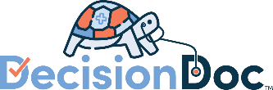
Cabinetworks Group 2023
Instructions for Decision Doc – Email Template

Email Template to HR Managers – Instructions for Decision Doc
Use the below email template to send to HR managers, requesting individual locations promote Decision Doc to their employees.
Dear HR Managers,
We’re pleased to announce that we are continuing our partnership with MyHealthMath for the 2023 benefits year! Their easy-to-use platform, Decision Doc, makes it easy to better understand health plan options and feel more confident about benefits choices – at no extra cost! Employees who use Decision Doc save over $1,300 a year on average.
We’ve attached some materials to print out and post in break rooms, near time clocks, post electronically on plant monitors, or anywhere else you think employees will see the materials. This will assist in promoting Decision Doc to employees and ensure that employees are enrolling in their optimal benefits for 2023.
Questions about Decision Doc? Please email the MyHealthMath team at questions@myhealthmath.com.
Thank you for your assistance in helping to promote Decision Doc!
Sincerely,
Cabinetworks Group

