ENTRUST Solutions Group
Benefit Guide Language

Benefit Guide
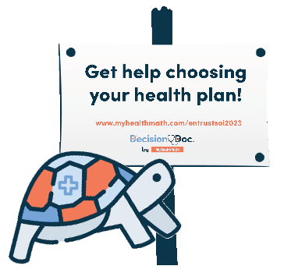
Standalone Introduction to Decision Doc
Choosing your health plan just got easier
Choosing a plan can be difficult, but Decision Doc makes it easy! Use the free, confidential, and secure platform to receive a personalized report showing which plan will save you the most money based on your specific needs.
Here’s how it works:
- Go to Decision Doc: www.myhealthmath.com/entrustsol2023
- Answer some questions about you and your family’s specific medical needs and prescriptions.
- Receive a personalized report showing which plan will get you the most cost-effective coverage.
Live analysts are also available to help you during the entire process.
Language to include throughout your Benefit Guide
Available to all employees!
This year, we’ve made sure Decision Doc is available to all employees selecting a plan. It takes just a few minutes to learn about the plan options available to you, so you can feel confident in your enrollment decision. Get started here, www.myhealthmath.com/entrustsol2023 and reach out to questions@myhealthmath.com if you need support with Decision Doc!
Need some help?
Health insurance can be confusing, and there is more to consider than just what comes out of each paycheck! Use Decision Doc to receive personalized guidance that will help you evaluate your total health care cost on each of our plans. Access Decision Doc here: www.myhealthmath.com/entrustsol2023.
Is an HSA right for you?
There’s a lot to learn about high deductible health plans (HDHPs) and Health Savings Accounts (HSAs) before you can know if these are right for you and your family. Use Decision Doc (www.myhealthmath.com/entrustsol2023) to learn more about these plans and compare how they stack up against all our plan options. It’s a quick and easy tool to help you feel confident before making your decision!
What’s the difference?
Health Savings Accounts (HSAs) and Flexible Spending Accounts (FSAs) can help you pay for certain healthcare expenses but there are some key differences you should know about! Take a few minutes to use Decision Doc (www.myhealthmath.com/entrustsol2023), a tool that can help you better understand how these accounts work with our plan options.

