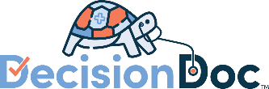
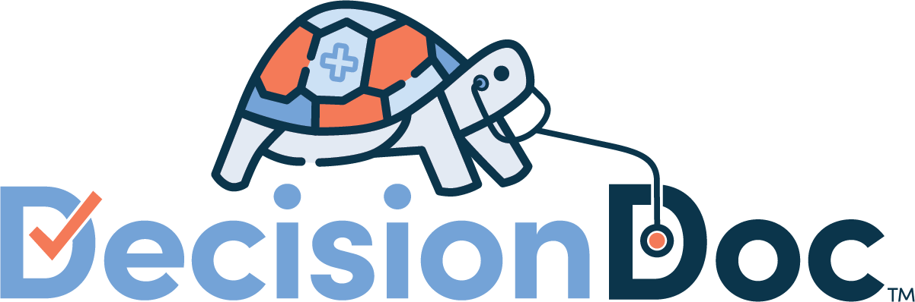
Communication Strategy for Open Enrollment 2023
Griffith Foods Group
CONTENTS

Open Enrollment Highlights 1
Short Messaging Blurbs 1
Intranet and Benefit Communications 2
Enrollment Platform 2
Benefit Guide 2
Additional Blurbs for Open Enrollment Communications 3
Email Templates 4
Intro to Decision Doc 4
Additional Email - General Language 4
Additional Email - From your Executive Leadership 5
FAQs 6

Open Enrollment Highlights

- Health Plan Effective Date: 01/01/2023
- Open Enrollment Period: 10/3/2022 – 11/4/2022
- Decision Doc Proposed Go Live Date*: 9/26/2022
- Decision Doc URL: www.myhealthmath.com/griffithfoods2023

Short Messaging Blurbs

Intranet and Benefit Communications
Which plan is best for you?
This is a tricky question that is different for every employee. That’s why we’ve made Decision Doc available to all employees. Check out this short video to learn more, and get your personalized support here: www.myhealthmath.com/griffithfoods2023
Have you used Decision Doc yet?
Decision Doc is free and available to all benefit eligible employees. This confidential platform takes just 5-6 minutes to complete and can help you learn which plan will work best for you. Many employees aren’t in their optimal plan or don’t know where to start when choosing one. Folks who use Decision Doc save an average of $1,300! Visit www.myhealthmath.com/griffithfoods2023 to get help today.
To include with your HR contact information in communications
Have questions about our plan options? Utilize Decision Doc to receive personalized guidance. Check out this short video to learn more, and get started here: www.myhealthmath.com/griffithfoods2023

Enrollment Platform
Still have questions?
Selecting a plan is a big decision. For help seeing which plan will match your specific medical and pharmacy needs, make sure you use Decision Doc! Available at www.myhealthmath.com/griffithfoods2023, Decision Doc is a completely confidential tool that show you how much money you could expect to spend on each plan, based on your specific health circumstances.
Last chance for personalized support!
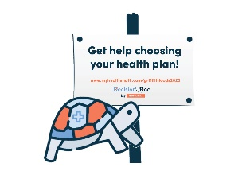
Before you enroll, make sure to check out Decision Doc: www.myhealthmath.com/griffithfoods2023. Decision Doc can help you make sure you select the plan that will save you and your family the most money for the upcoming year!

Benefit Guide
Standalone Introduction to Decision Doc
Choosing your health plan just got easier
Choosing a plan can be difficult, but Decision Doc makes it easy! Use the free, confidential, and secure platform to receive a personalized report showing which plan will save you the most money based on your specific health needs.
Here’s how it works:
- Go to Decision Doc: www.myhealthmath.com/griffithfoods2023.
- Answer some questions about you and your family’s specific medical needs and prescriptions.
- Receive a personalized report showing which plan will get you the most cost-effective coverage.
Live analysts are also available to help you during the entire process.
Language to include throughout your Benefit Guide
Available to all employees!
This year, we’ve made sure Decision Doc is available to all employees selecting a plan. It takes just a few minutes to learn about the plan options available to you, so you can feel confident in your enrollment decision. Get started here, www.myhealthmath.com/griffithfoods2023 and reach out to questions@myhealthmath.com if you need support with Decision Doc!
Need some help?
Health insurance can be confusing, and there is more to consider than just what comes out of each paycheck! Use Decision Doc to receive personalized guidance that will help you evaluate the entire cost of our plans. Access Decision Doc here: www.myhealthmath.com/griffithfoods2023.
Is an HSA right for you?
There’s a lot to learn about high deductible health plans (HDHPs) and Health Savings Accounts (HSAs) before you can know if these are right for you and your family. Use Decision Doc (www.myhealthmath.com/griffithfoods2023) to learn more about these plans and compare how they stack up against all our plan options. It’s a quick and easy tool to help you feel confident before making your decision!
What’s the difference?
Health Savings Accounts (HSAs) and Flexible Spending Accounts (FSAs) can help you pay for certain healthcare expenses but there are some key differences you should know about! Take a few minutes to use Decision Doc (www.myhealthmath.com/griffithfoods2023), a tool that can help you better understand how these accounts work with our plan options.

Additional Blurbs for Open Enrollment Communications
- Hi Griffith Foods Group Employees! Open Enrollment is fast approaching, and we know that selecting the right plan can be difficult. Decision Doc is here to help! You’ll answer a few basic questions and receive a detailed report showing which plan is optimal for you and your family. It’s free, easy, and completely confidential. Head over to www.myhealthmath.com/griffithfoods2023 to get started.
- You’ve seen the flyers and emails - Decision Doc is available now! It’s quick, easy, and gives you instant plan recommendations. Ensure that you are in the optimal plan for the 2023 plan year by using the free and confidential tool. Check it out at: www.myhealthmath.com/griffithfoods2023
- Planning upcoming life changes? Use Decision Doc to ensure your plan provides the coverage you need. Answer some basic question about your upcoming medical usage and let Decision Doc do the rest! You’ll receive a personalized report that matches you to an optimal health plan. Get started today: www.myhealthmath.com/griffithfoods2023

Email Templates

Intro to Decision Doc
Subject: Introducing Decision Doc!
Send Date: 9/22
Attachments: Decision Doc OE Flyer_Griffith Foods Group 2023
Cc or Bcc: hrogers@myhealthmath.com; kalexander@myhealthmath.com

Hi all!

We’re pleased to announce that we are continuing our partnership with MyHealthMath for the 2023 benefits year. Decision Doc, their free, quick, and easy decision support platform, is available to everyone during Open Enrollment. Employees who use Decision Doc save over $1,300 a year on average

Keep an eye out for emails from MyHealthMath during open enrollment. They’ll be sending you a series of emails encouraging you to use Decision Doc, get support, and save! They’ll even be sharing some fun raffle opportunities, so make sure you’re checking your emails and not missing out.

Any emails from MyHealthMath will look like this:
- From address: communications@myhealthmath.com
- Sample Subject line: Don’t Choose a Health Plan in the Dark – Decision Doc Can Shed Some Light!

If you have any questions, don’t hesitate to reach out to them at questions@myhealthmath.com.

The team at MyHealthMath is looking forward to supporting you this Open Enrollment season!

Thank you,
Griffith Foods Group

Additional Email - General Language
Dear Griffith Foods Group Employees,
With Open Enrollment in full swing, we want to remind you that Decision Doc is available to help you select a plan, based on your personal needs. It takes just 5-6 minutes to answer some questions about your healthcare needs, and you’ll receive an instant report that shows you how much money you could expect to spend on each plan. MyHealthMath has been sending you email reminders (from communications@myhealthmath.com) but here’s the link again, for easy access: www.myhealthmath.com/griffithfoods2023.
All the best,
Griffith Foods Group

Additional Email - From your Executive Leadership
Dear Griffith Foods Group Employees,

I wanted to remind you that Decision Doc is available to all employees looking for help selecting a plan this year. The platform makes it easy for you to better understand your plan options and feel more confident about your choice — all at no extra cost to you. The secure platform that takes just 5-6 minutes to complete will help you choose a plan that best matches your specific health circumstances and gives you the best value.

Get started with Decision Doc today, before you make your final decision.

- Go to www.myhealthmath.com/griffithfoods2023
- Answer a few quick questions, either online or over the phone, about potential and planned medical services and prescriptions that you and your family members may need during the benefit year.
- You’ll receive an instant report detailing your possible expenses for the plan year – you can save this report, try out different usage scenarios, and even email the report to a partner at home.

Questions about Decision Doc or your personalized report? Email the MyHealthMath team at questions@myhealthmath.com.

Sincerely,

Griffith Foods Group

FAQs

Q. What is Decision Doc?
A. Decision Doc is MyHealthMath’s interactive online platform that helps employees choose an optimal health plan. You will go through a series of questions, either online or on the phone, and then receive an interactive report showing which health plan will save you the most money in the coming year. Decision Doc integrates phone and online support, reporting, education, and resources.
Q. Who is MyHealthMath?
A. MyHealthMath (MHM) is a decision support company whose mission is to simplify health insurance purchasing, so employees across the country get the best value from their healthcare dollar. MyHealthMath uses a highly accurate algorithm, paired with personalized employee engagement, to identify the optimal health plan for individuals.
Q. Do I have to prepare anything before using Decision Doc?
A. You should be prepared to answer questions on medical usage and history for you and your dependents. Decision Doc collects basic health usage information, such as frequency of doctor visits, medications, planned surgeries, etc. Names and dosages of prescriptions can dramatically affect costs, so we recommend writing these down before you go to Decision Doc, for yourself and any dependents you’re thinking of including on your plan.
Decision Doc takes 5-6 minutes when completed online. The phone interviews typically take 15 minutes.
Q. Will my personal information remain secure?
A. Absolutely! MHM is an independent third party that abides by rigorous security standards. They will never share your personal information with us, our insurance carrier or any other third part.
Q. What if I have questions about my results?
A. The MHM team is available to answer any questions you have about how to interpret your results. You can reach them via email (questions@myhealthmath.com) or schedule a call through the option directly on your Decision Doc results page!
Q. Will Decision Doc enroll me in a plan?
A. No. Decision Doc is a tool to help you make a decision. You can run as many health scenarios as you’d like to ensure you find the plan that works for you. Once you make that decision, you will enroll in our plans (and any associated HSA/FSA plan) through our regular enrollment process.

