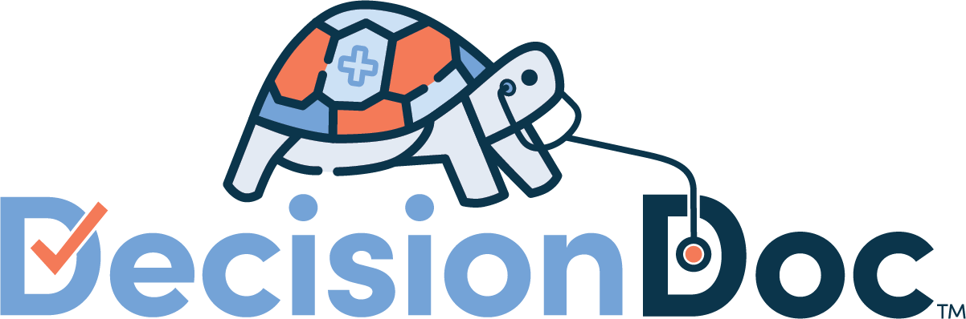
Short Messaging Blurbs
IDEXX

Short Messaging Blurbs

Workday & Ask HR
Don’t choose your benefits in the dark. Use Decision Doc to get your personalized plan choice guidance.
- To be paired with Decision Doc Reminder Icon!
Decision Doc: Get plan choice guidance here!
- To be paired with Decision Doc Reminder Icon!
Still have questions?
Selecting a plan is a big decision. For help seeing which plan will match your specific medical and pharmacy needs, make sure you use Decision Doc! Available at www.myhealthmath.com/idexx2023, Decision Doc is a completely confidential tool that shows your total health care costs on each plan, based on your specific health circumstances. View your Decision Doc results and automatically receive 2,000 Virgin Pulse Points!
Which plan is best for you?
This is a tricky question, but Decision Doc can help you find out. You’ll start by viewing your Claims Snapshot. If you were enrolled in one of the IDEXX health plans last year, Decision Doc will rank your current health plans based on your past medical claims’ history. Then, you’ll go through a series of questions about your upcoming healthcare needs. You can answer these questions online or speak directly to an agent who can walk you through the questions over the phone. Check out this short video to learn more, and get your personalized support here: www.myhealthmath.com/idexx2023. As an added bonus, IDEXX employees who view their Decision Doc results will automatically receive 2,000 Virgin Pulse Points!
Have you used Decision Doc yet?
Decision Doc is free and available to all benefit eligible employees. This confidential platform takes just 5-6 minutes to complete and can help you learn which plan will work best for you (and it includes a claims-based analysis!). Many employees aren’t in their optimal plan or don’t know where to start when choosing one, so live agents are available every step of the way. Folks who use Decision Doc save an average of $1,300! Visit www.myhealthmath.com/idexx2023 to get help today (you’ll also receive 2,000 Virgin Pulse Points, just for learning about our plan options!).
Last chance for personalized support!
Before you enroll, make sure to check out Decision Doc: www.myhealthmath.com/idexx2023. Decision Doc can help you select the plan that will save you and your family the most money for the upcoming year! Here’s what makes Decision Doc uniquely effective:
- Your claims snapshot: Employees who used one of IDEXX’s health plans for the past year will get their personal Claims Snapshot! Snapshots show you which health plan will save you the most money based on your past medical claims’ history.
- Factor in future needs: Answer a series of questions about your upcoming healthcare needs for even more personalized guidance.
- One-on-one support: You can answer these question online or schedule a phone call with an agent. Agents are available at every step to help answer any questions you have about Decision Doc.

Blurb to include with your contact information
Have questions about our plan options? Utilize Decision Doc to receive personalized guidance. Check out this short video to learn more, and get started here: www.myhealthmath.com/idexx2023

Benefits Handbook Language
Standalone Introduction to Decision Doc
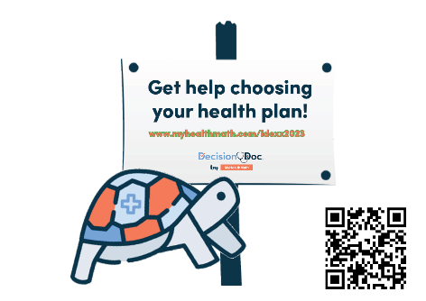
Choosing your health plan just got easier
Choosing a health plan can be difficult, but Decision Doc makes it easy! Use the free, confidential, and secure platform to receive a personalized report showing which health plan will save you the most money based on your specific health needs.
Here’s how it works:
- Go to Decision Doc: www.myhealthmath.com/idexx2023.
- View your Claims Snapshot. If you have been enrolled in one of the IDEXX health plans for the past year, your Snapshot will show you which health plan will save you the most money based on your past medical claims’ history.
- Answer some questions about you and your family’s upcoming medical needs and prescriptions.
- Receive a personalized report showing which health plan will get you the most cost-effective coverage. Plus, automatically receive 2,000 Virgin Pulse Points!
Live agents are also available to help you during the entire process. Schedule a call directly through Decision Doc, or email the team at questions@myhealthmath.com.
Language to include throughout your Benefits Handbook
Available to all employees!
This year, we’ve made sure Decision Doc is available to all employees selecting a health plan. It takes just a few minutes to learn about the plan options available to you, so you can feel confident in your enrollment decision. Get started here, www.myhealthmath.com/idexx2023 and reach out to questions@myhealthmath.com if you need support with Decision Doc!
Need some help?
Health insurance can be confusing, and there is more to consider than just what comes out of each paycheck! Use Decision Doc to receive personalized guidance (online or over the phone) that will help you evaluate your total health care cost on each of our plans. Access Decision Doc here: www.myhealthmath.com/idexx2023.
Is an HSA right for you?
There’s a lot to learn about high deductible health plans (HDHPs) and Health Savings Accounts (HSAs) before you can know if these are right for you and your family. Use Decision Doc (www.myhealthmath.com/idexx2023) to learn more about these plans and compare how they stack up against all our plan options. It’s a quick and easy tool, with live agents available to help you feel confident before making your decision!
What’s the difference?
Health Savings Accounts (HSAs) and Flexible Spending Accounts (FSAs) can help you pay for certain healthcare expenses but there are some key differences you should know about! Take a few minutes to use Decision Doc (www.myhealthmath.com/idexx2023), a tool that can help you better understand how these accounts work with our plan options.

Virgin Pulse Program
- Hi IDEXX Employees! Open Enrollment is fast approaching, and we know that selecting the right health plan can be difficult. Decision Doc is here to help! You’ll answer a few basic questions (online or over the phone) and receive a detailed report showing which health plan is optimal for you and your family. It’s free, easy, and completely confidential. Head over to www.myhealthmath.com/idexx2023 to get started. Once you view your results, you’ll automatically receive 2,000 Virgin Pulse Points.
- You’ve seen the flyers and emails - Decision Doc is available now! It’s quick, easy, and gives you instant health plan guidance. Employees who have been enrolled in an IDEXX plan for the past year will also have the option to see which health plan will save the most money based on your past medical claims’ history. Ensure that you are in the optimal health plan for the 2023 plan year by using the free and confidential tool (and receive 2,000 Virgin Pulse Point while you’re at it!). Check it out at: www.myhealthmath.com/idexx2023
- Planning upcoming life changes? Use Decision Doc to ensure your health plan provides the coverage you need. Answer some basic question about your upcoming medical usage, online or with an agent over the phone, and let Decision Doc do the rest! You’ll receive a personalized report that matches you to an optimal health plan. When you’re done, you’ll also receive 2,000 Virgin Pulse Points! Get started today: www.myhealthmath.com/idexx2023

