Benefit Guide Language

PMA Consultants

**Standalone Introduction to Decision Doc**

**Choosing your health plan just got easier**

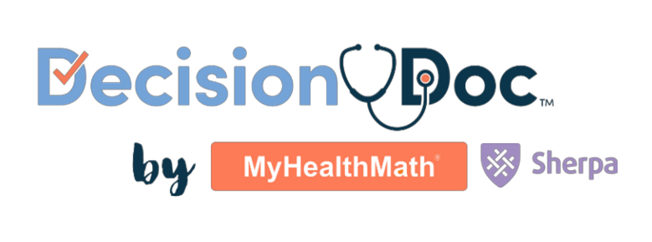Choosing your benefits can be difficult, but Decision Doc makes it easy! Use the free, confidential, and secure platform to receive a personalized protection score and guidance on how to improve your overall financial wellness through the benefits available to you.

Here’s how it works:

1. Go to Decision Doc: <www.myhealthmath.com/pma2023>.
2. Answer some questions about your health care needs, finances and family.
3. Receive a personalized Protection Score and guidance on how to improve your overall financial wellness.

Questions about Decision Doc? Connect with MyHealthMath at [questions@myhealthmath.com](mailto:questions@myhealthmath.com).

**Language to include in different places throughout your Benefit Guide**

**Available to all employees!**

This year, we’ve made sure Decision Doc, is available to all employees selecting their benefits. It takes just a few minutes to learn about the benefits available to you, so you can feel confident in your enrollment decision. Get started here, <www.myhealthmath.com/pma2023> and reach out to [questions@myhealthmath.com](mailto:questions@myhealthmath.com) if you need support with Decision Doc!

**Need some help?**

Selecting a benefits package can be confusing, and there is more to consider than what comes out of each paycheck! Use Decision Doc, to receive personalized guidance that will help you evaluate your benefit options. Access Decision Doc here: <www.myhealthmath.com/pma2023>.

**What’s the difference?**

Health Savings Accounts (HSAs) and Flexible Spending Accounts (FSAs) can help you pay for certain healthcare expenses, but there are some key differences you should know about! Take a few minutes to use Decision Doc, a tool that can help you better understand how these accounts work with our plan options: <www.myhealthmath.com/pma2023>