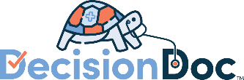
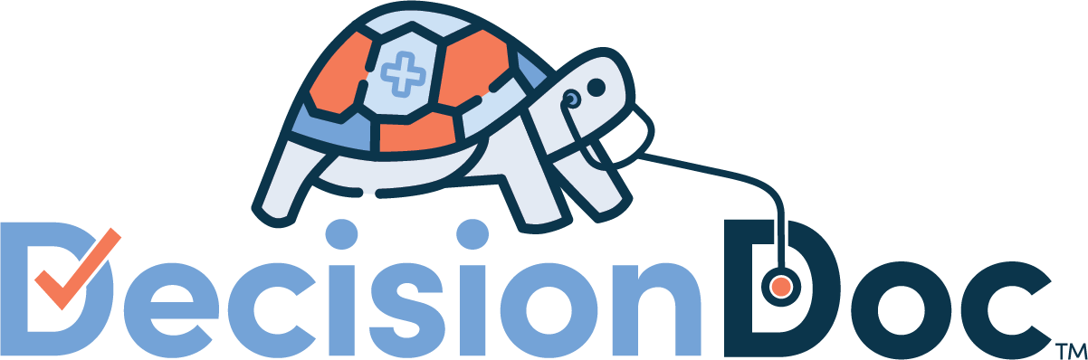
Short Messaging Blurbs
Unum

MyBenefits Site
Don’t choose your benefits in the dark. Use Decision Doc to get your personalized benefit guidance.
- To be paired with the Decision Doc Icon
Decision Doc: Get benefit guidance here!
- To be paired with the Decision Doc Icon
Still have questions?
Selecting a benefit package is a big decision. For help seeing which benefits will match your specific health and financial needs, make sure you use Decision Doc, powered by Sherpa Score! Available at www.myhealthmath.com/unum2023, Decision Doc is a completely confidential tool that provides you with a personalized Protection Score and guidance on how to improve your overall financial wellness.
Which plans are best for you?
This is a tricky question that is different for every employee. That’s why we’ve made Decision Doc, powered by Sherpa Score, available to all employees. Check out this short video to learn more, and get your personalized support here: www.myhealthmath.com/unum2023
Have you used Decision Doc yet?
Decision Doc, powered by Sherpa Score is free and available to all benefit eligible employees. This confidential platform takes just 5-6 minutes to complete and can help you learn which benefits will work best for you. Many employees don’t select the right benefits, or don’t know where to start when choosing their plans. Folks who use Decision Doc save an average of $1,300 on health care costs! Visit www.myhealthmath.com/unum2023 to get help today.
Last chance for personalized support!
Before you enroll, make sure to check out Decision Doc, powered by Sherpa Score: www.myhealthmath.com/unum2023. Decision Doc can help you make sure you select the benefit package that will save you and your family the most money for the upcoming year!
Blurb to pair with your contact information
Have questions about our benefit package? Utilize Decision Doc, powered by Sherpa Score to receive personalized guidance. Check out this short video to learn more, and get started here: www.myhealthmath.com/unum2023

Newsletter Language
Standalone Introduction to Decision Doc
Choosing your benefits package just got easier
Choosing your benefits can be difficult, but Decision Doc makes it easy! Use the free, confidential, and secure platform to receive a personalized protection score and guidance on how to improve your overall financial wellness through the benefits available to you.
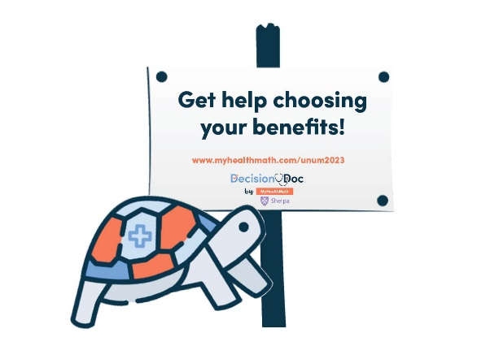
Here’s how it works:
- Go to Decision Doc: www.myhealthmath.com/unum2023.
- Answer some questions about your health care needs, finances and family.
- Receive a personalized Protection Score and guidance on how to improve your overall financial wellness.
Questions about Decision Doc? Email questions@myhealthmath.com for support.
Additional Language
Available to all employees!
This year, we’ve made sure Decision Doc, powered by Sherpa Score is available to all employees selecting their benefits. It takes just a few minutes to learn about the benefits available to you, so you can feel confident in your enrollment decision. Get started here, www.myhealthmath.com/unum2023 and reach out to questions@myhealthmath.com if you need support with Decision Doc!
Need some help?
Selecting a benefits package can be confusing, and there is more to consider than just what comes out of each paycheck! Use Decision Doc, powered by Sherpa Score to receive personalized guidance that will help you evaluate your benefit options. Access Decision Doc here: www.myhealthmath.com/unum2023.
Is an HSA right for you?
There’s a lot to learn about high deductible health plans (HDHPs) and Health Savings Accounts (HSAs) before you can know if these are right for you and your family. Use Decision Doc, powered by Sherpa Score (www.myhealthmath.com/unum2023) to learn more about these plans and compare how they stack up against all our plan options. Plus, receive a personalized Protection Score and guidance on how to improve your overall financial wellness. It’s a quick and easy tool to help you feel confident before making your decision!

Messenger App
- Hi Unum Employees! Open Enrollment is fast approaching, and we know that selecting the right benefits package can be difficult. Decision Doc, powered by Sherpa Score, is here to help! You’ll answer a few basic questions and receive a personalized Protection Score and guidance on how to improve your overall financial wellness. It’s free, easy, and completely confidential. Head over to www.myhealthmath.com/unum2023 to get started.
- You’ve seen the flyers and emails - Decision Doc, powered by Sherpa Score is available now! It’s quick, easy, and gives you instant guidance on how to select the right benefits package for your specific needs. Ensure that you are in the optimal plans for the 2023 plan year by using the free and confidential tool. Check it out at: www.myhealthmath.com/unum2023
- Planning upcoming life changes? Use Decision Doc, powered by Sherpa Score, to ensure your benefit package provides the coverage you need. Answer some basic question about your healthcare, finances and family, and let Decision Doc do the rest! You’ll receive a personalized Protection Score and guidance on how to improve your overall financial wellness. Get started today: www.myhealthmath.com/unum2023

